**Test Results on 4/20/2017**

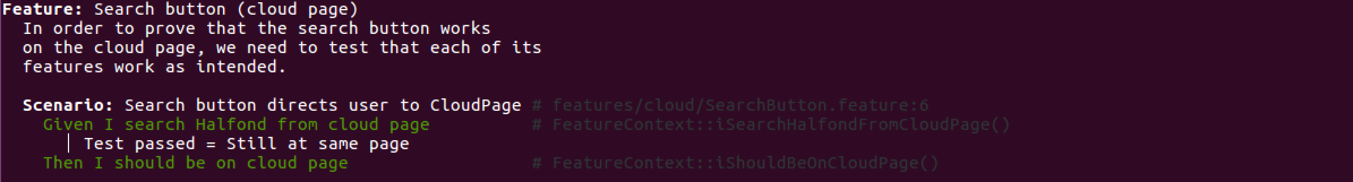Feature: Search button (cloud)

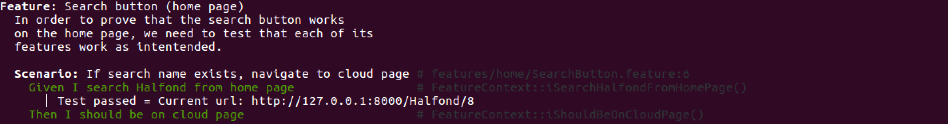Feature: Search button (home)

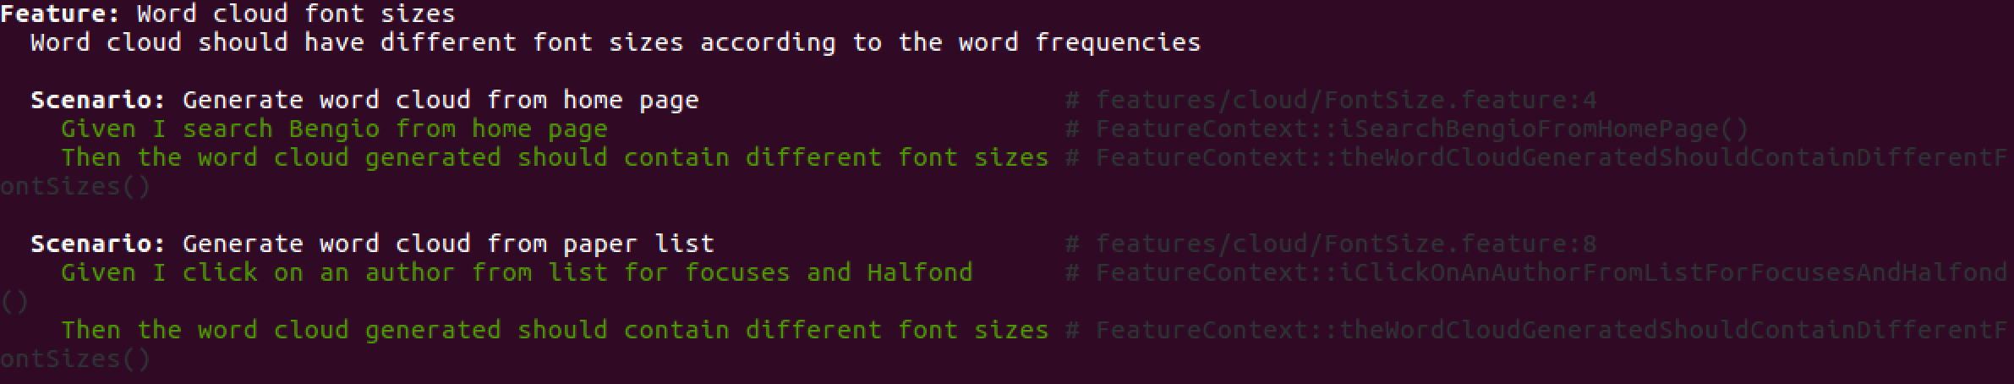Feature: Word cloud font sizes

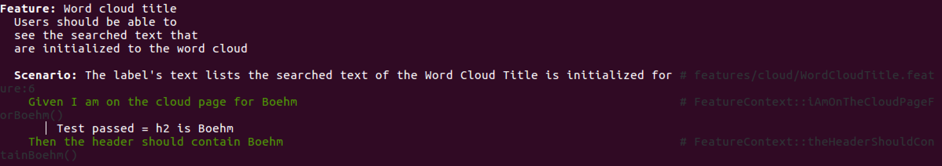Feature: Word cloud title

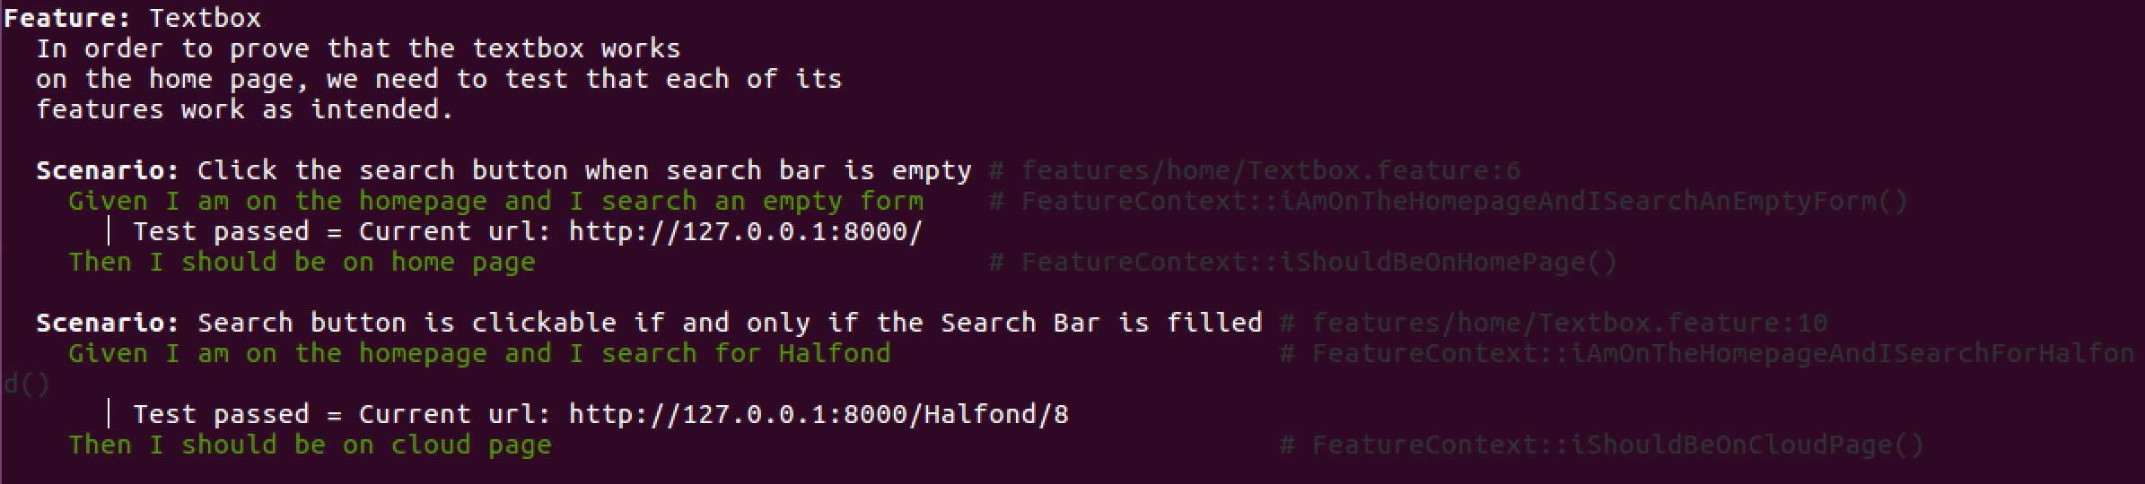Feature: Textbox

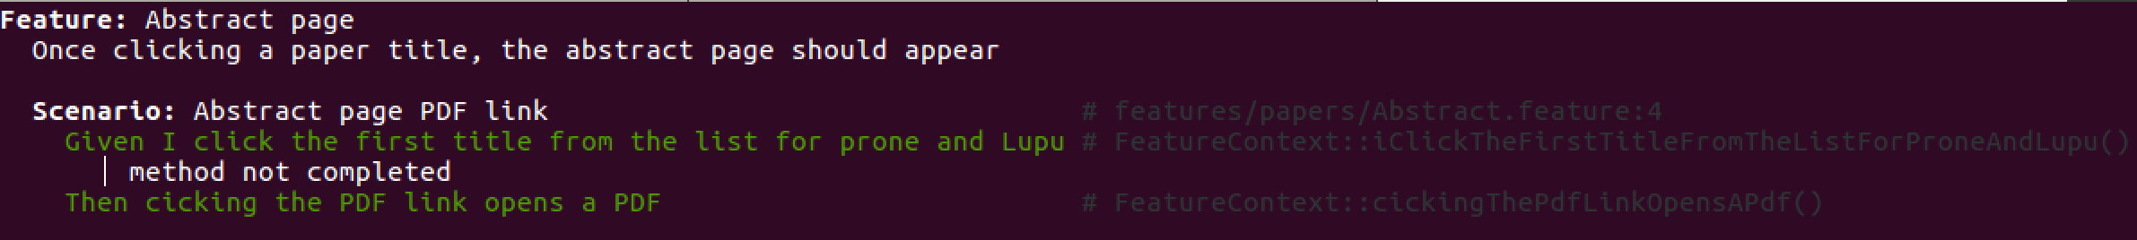Feature: Abstract page

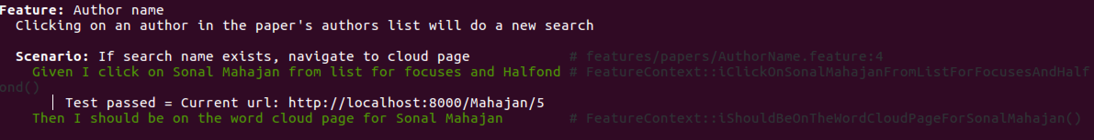Feature: Author name

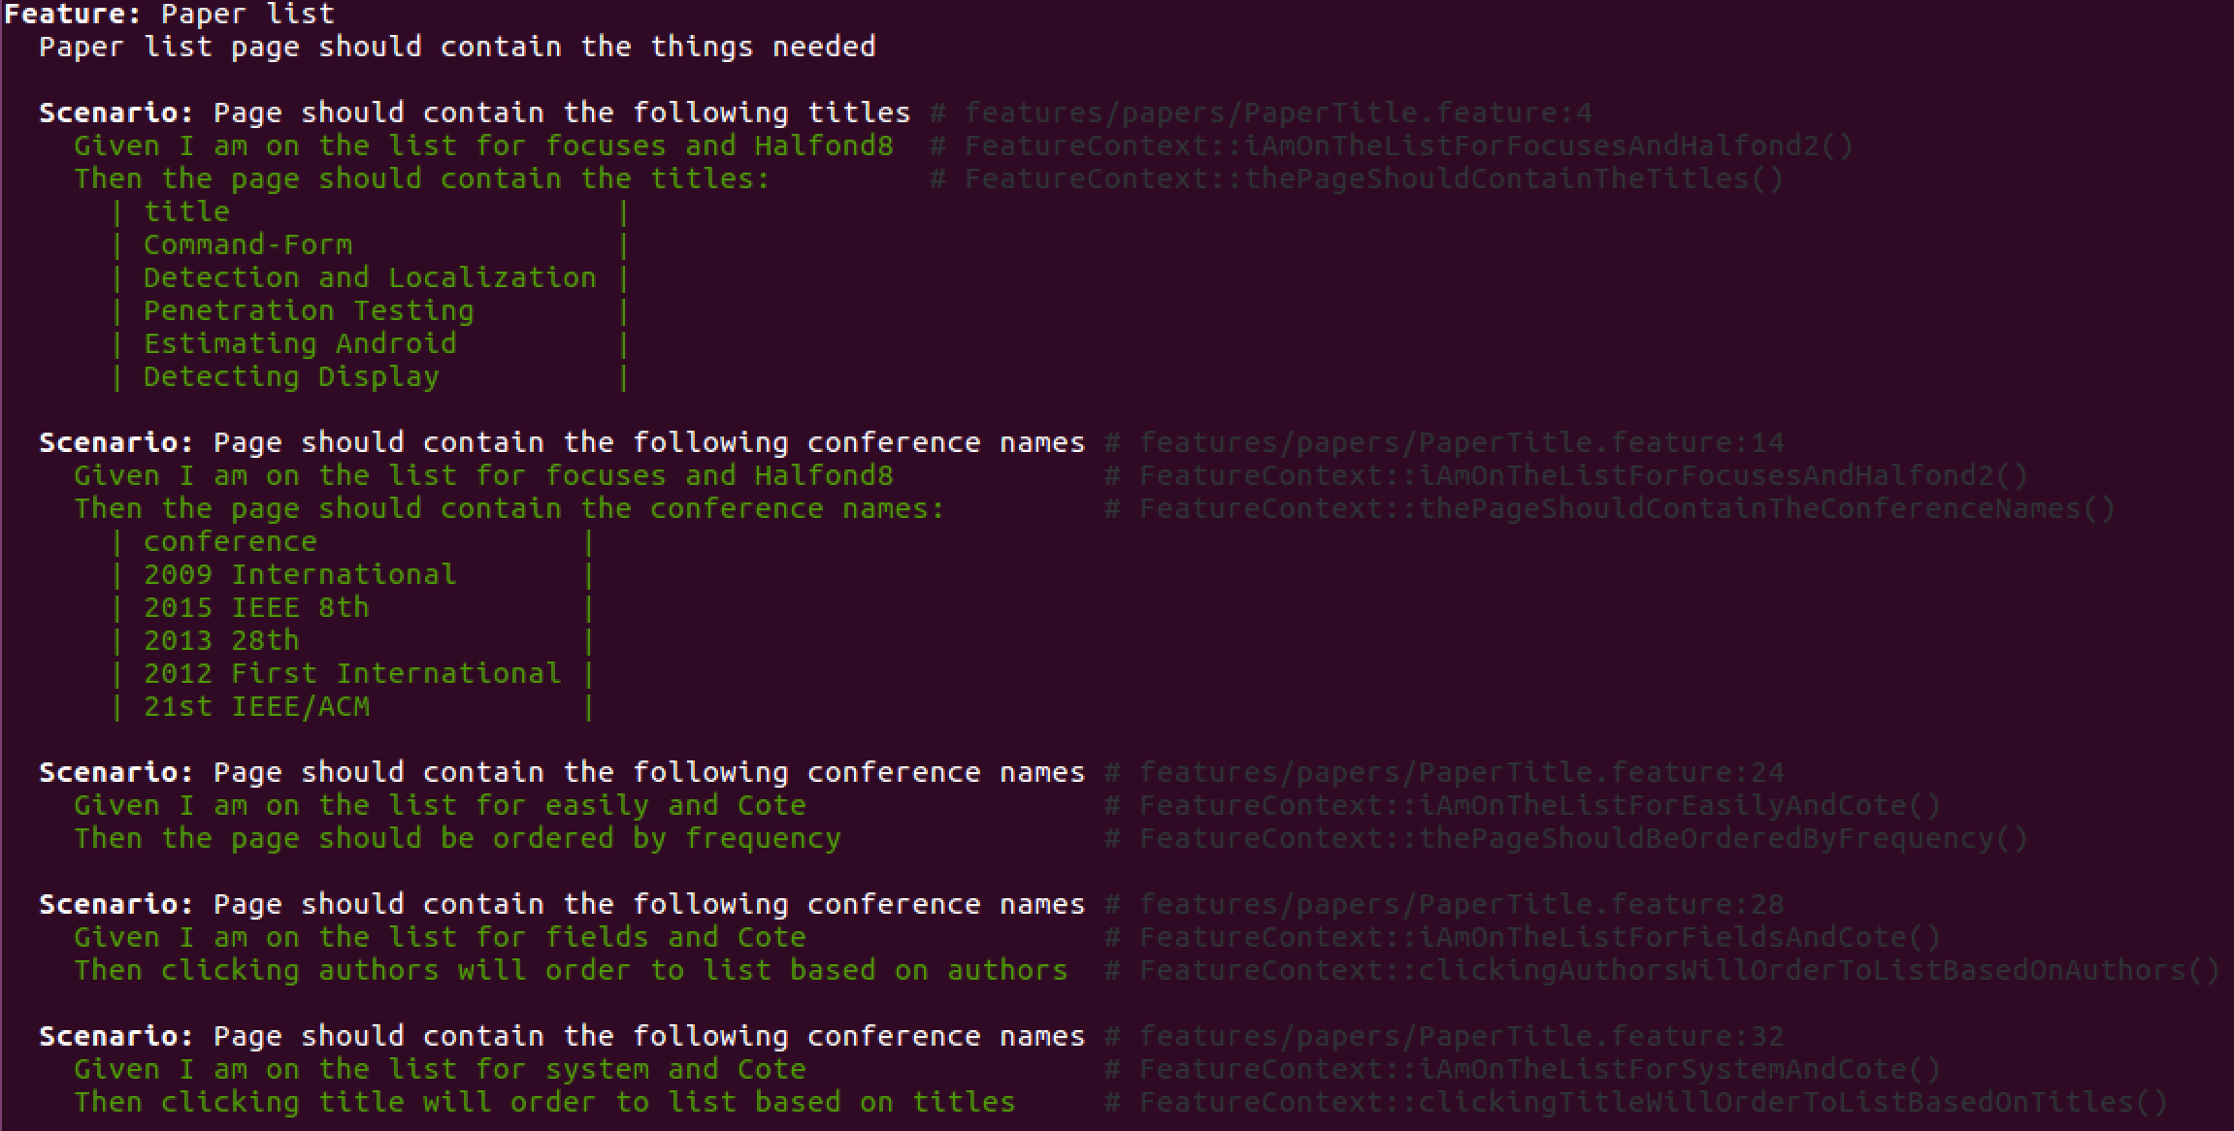Feature: Paper list

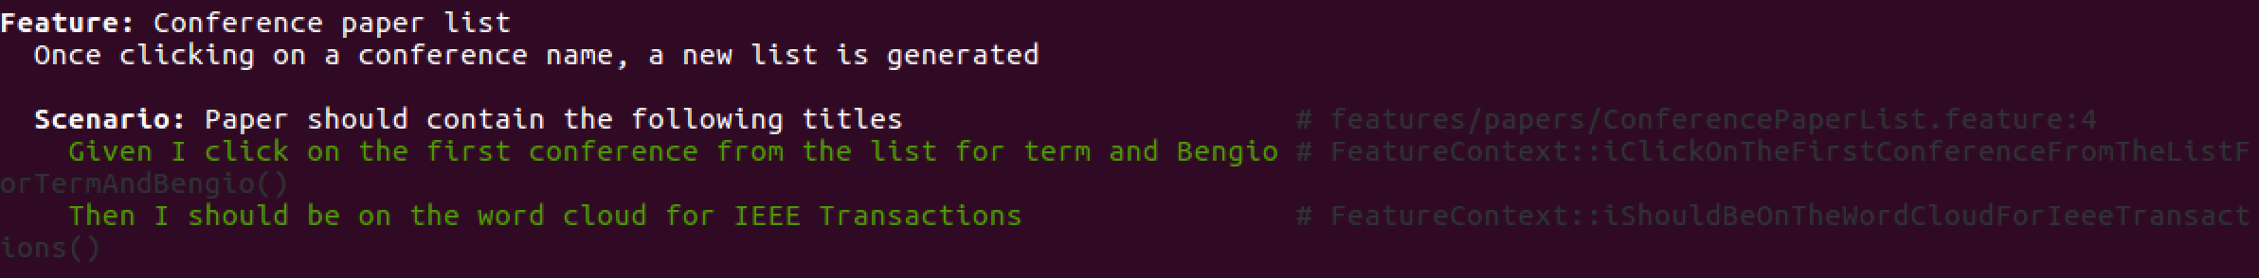Feature: Conference word cloud

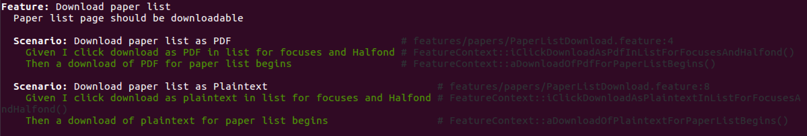Feature: Paper list download

Feature: Word cloud download



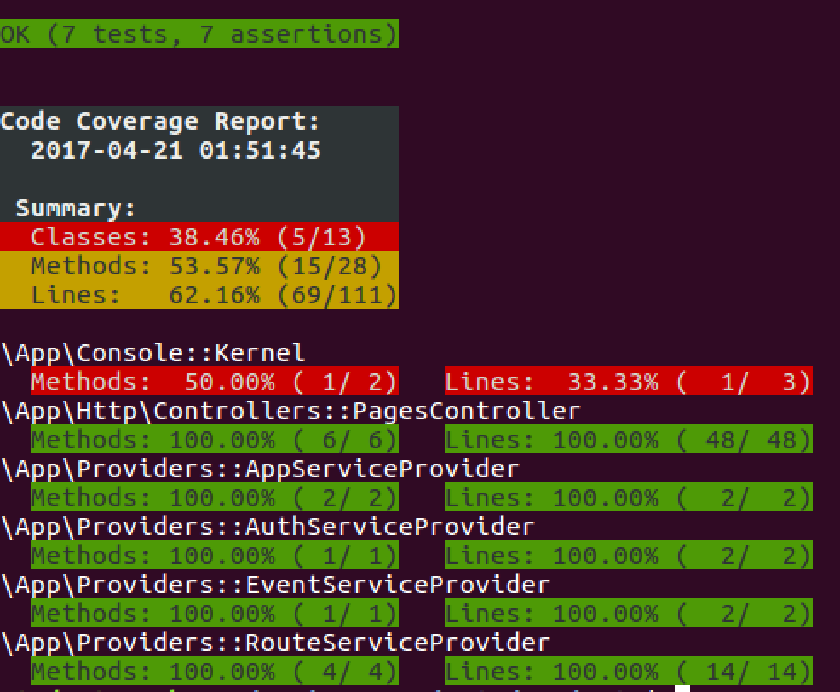Unit testing